🔍 HTTP Traffic Analysis — Quick Lab

Author: Obiora Emmanuel Ikechukwu
Project: HTTP Traffic Analysis & Credential Exposure
Date: 08-11-2025

Summary
I captured local HTTP traffic to show how unencrypted requests can expose sensitive data — then compared that to HTTPS to see how encryption protects it.

Why this matters
Plain HTTP sends text anyone can read on the network - usernames, cookies, and form data can be intercepted. This lab shows that difference visually and practically using Wireshark.

What I built
- A short capture of HTTP traffic (local test server and a public non-HTTPS site).
- A Wireshark analysis highlighting exposed request headers, cookies, and credentials.
- A simple comparison showing the same exchange over HTTPS (encrypted).

Environment
Linux VM (Ubuntu/Kali), Wireshark, Python 3, Browser (Firefox/Chrome).

Quick checklist (what I did)
- Started local HTTP server: python3 -m http.server 8080
- Captured traffic in Wireshark on eth0 (or any)
- Filtered HTTP: http and followed TCP streams
- Compared with HTTPS traffic: tls / http filter

Skills You’ll Learn
- How to capture HTTP requests/responses
- How to follow TCP and HTTP streams
- How credentials and data appear in plaintext (insecurely)
- Difference between HTTP and HTTPS in Wireshark captures

Step-by-Step Guide

Step 1: Start Wireshark
- Open Wireshark in your Linux VM.
- Select your network interface — usually eth0 or ens33 (for bridged/NAT networks).
- Click “Start Capturing Packets.”

Run your own HTTP server
In a terminal, run:
mkdir ~/http_project && cd ~/http_project
echo "Hello Wireshark!" > index.html
python3 -m http.server 8080
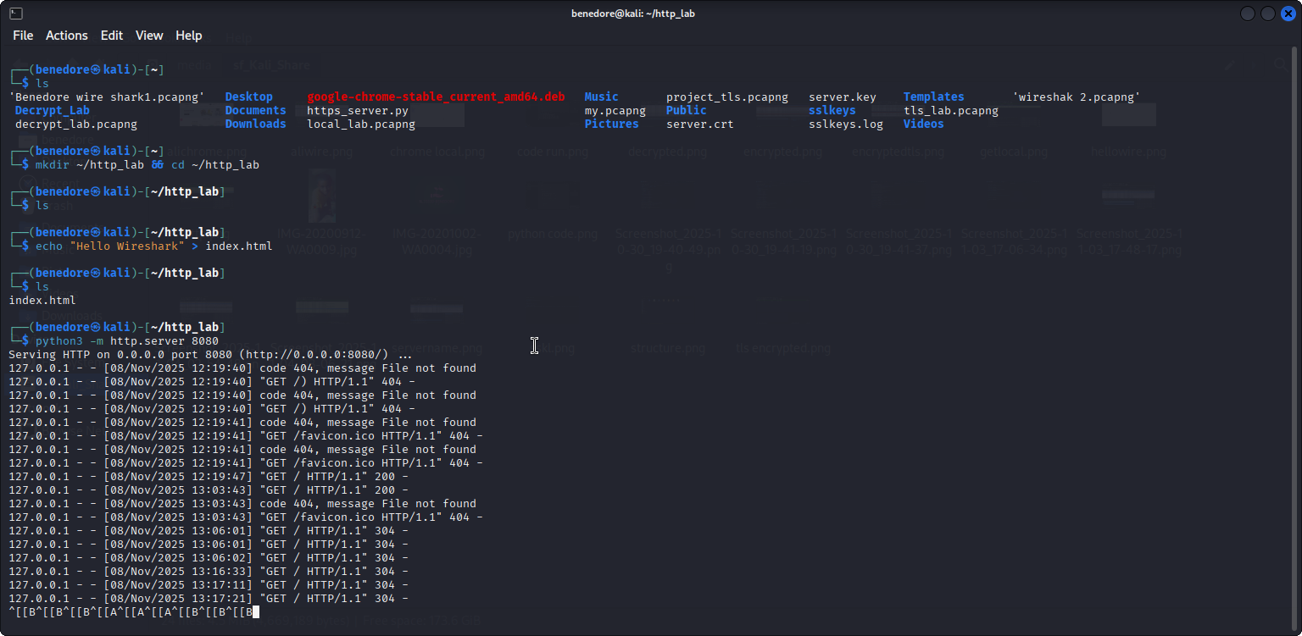

Now visit in browser: http://localhost:8080
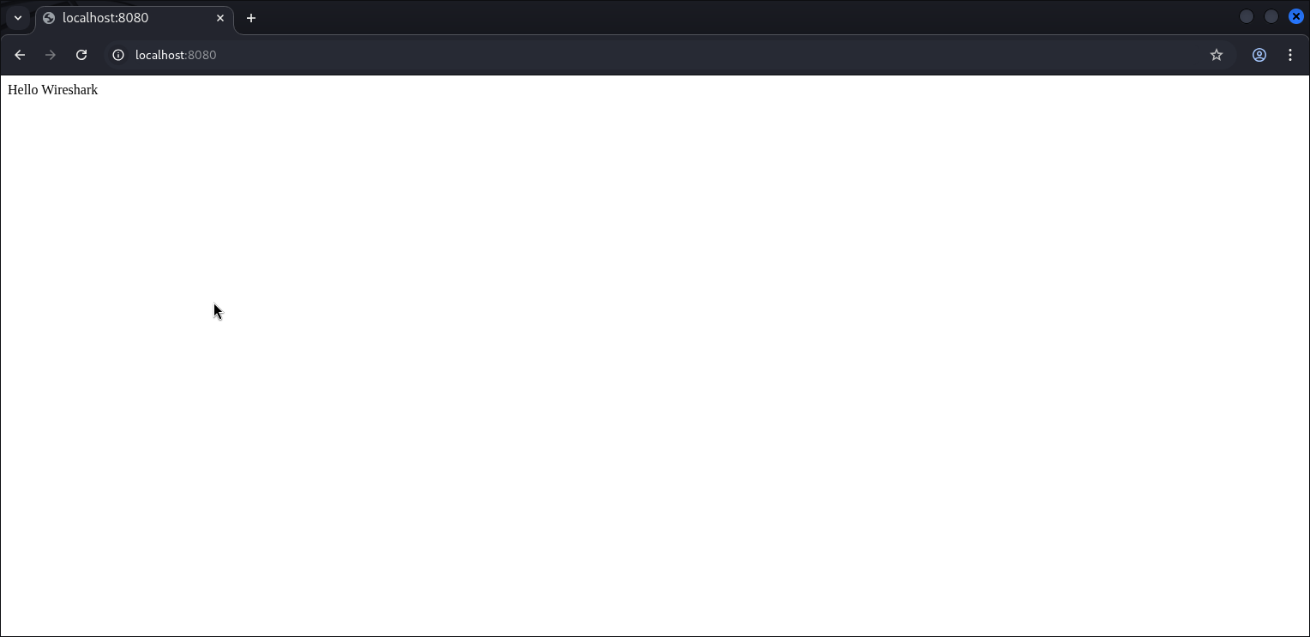

Step 3: Filter HTTP Packets
In Wireshark, apply this filter:
Http
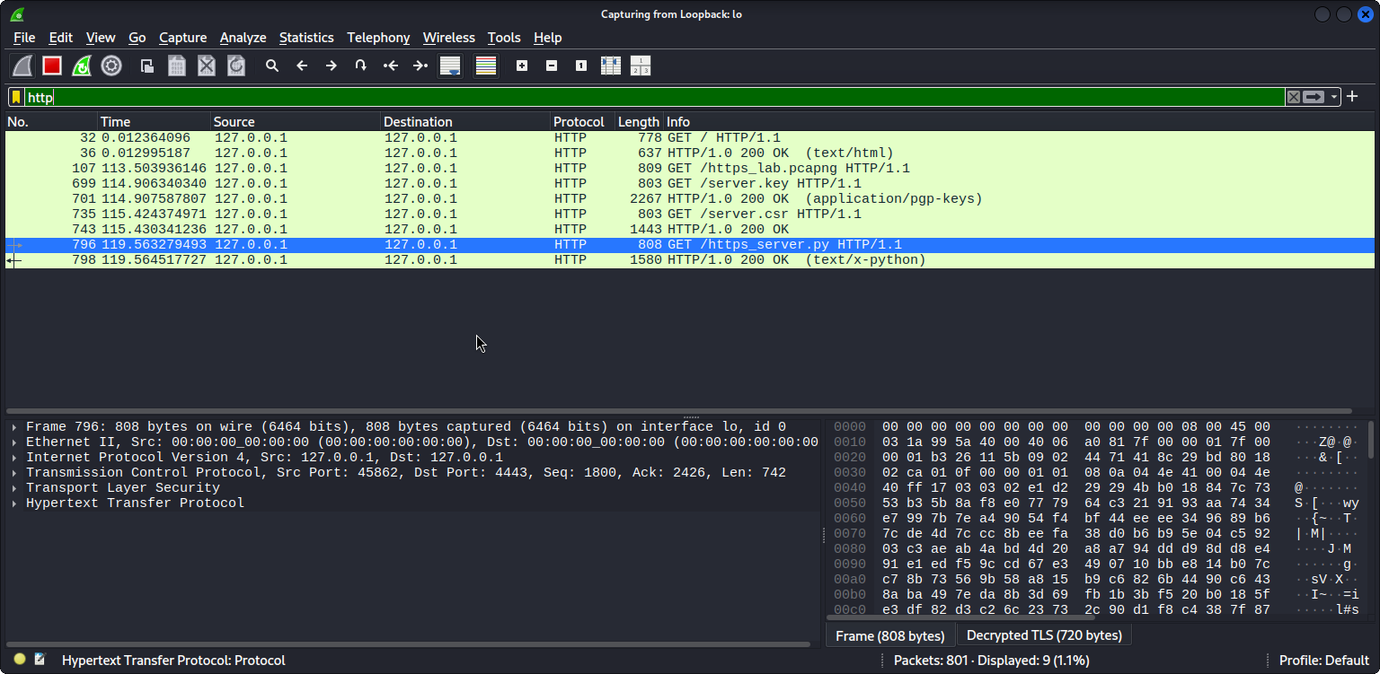
You’ll now see HTTP GET and POST requests, status codes, and responses.

Step 4: Analyze Requests
Click on any HTTP packet → expand:
Look at:
- Request Method: GET or POST
- Host: target website
- User-Agent: browser type
- Cookies: stored data
- Authorization (if used): sometimes shows Base64-encoded credentials
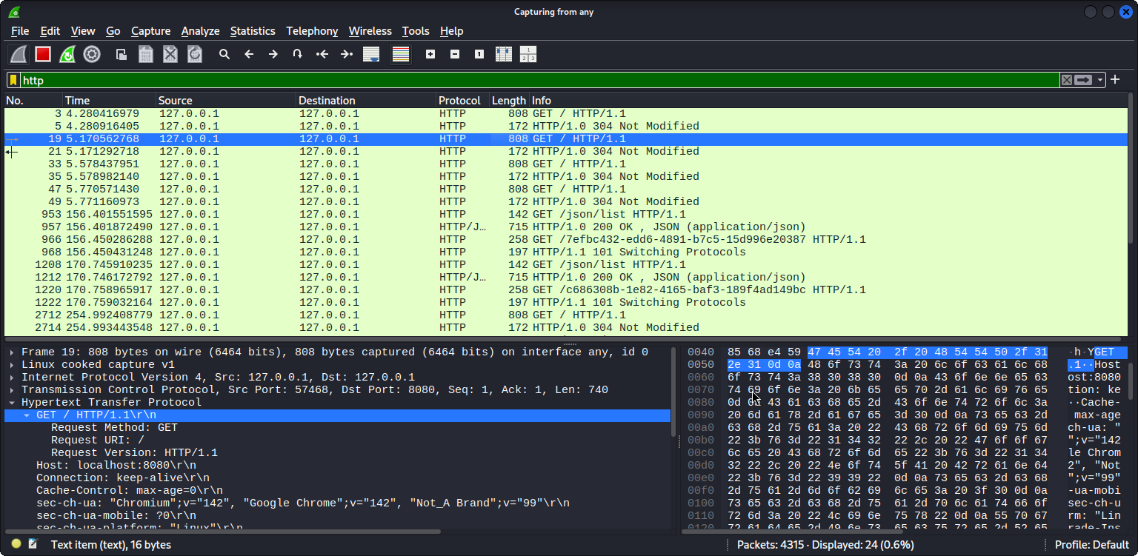

Step 5: Follow TCP Stream
Right-click any HTTP packet →
Follow → TCP Stream
You’ll see the entire conversation in one view — including request and server reply, such as:

You can decode the Base64 to reveal the username and password.
Run this in terminal: echo dXNlcjpwYXNzd29yZA== | base64 -d
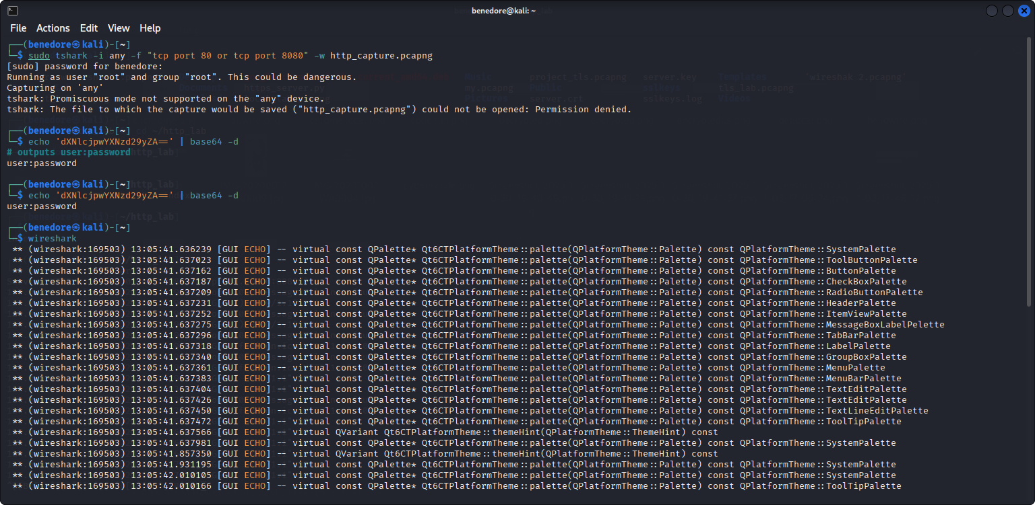

Step 6: Observe HTTP vs HTTPS
Now, visit any HTTPS site, e.g.: Aliexpress


Apply the same Wireshark filter: Http or Tls
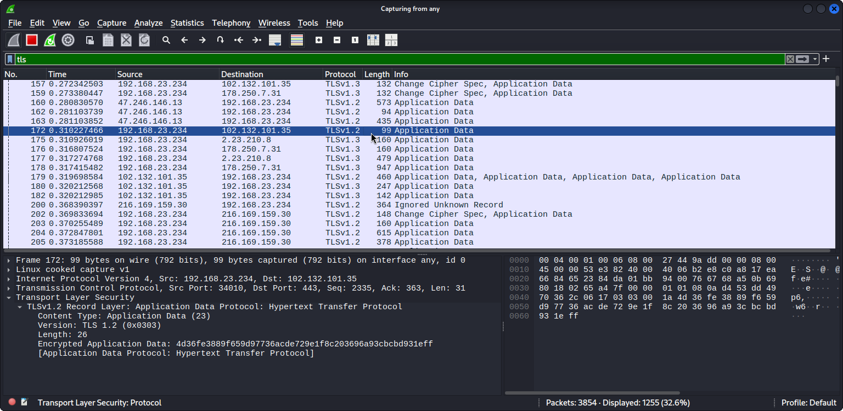

Notice:
- HTTP requests disappear (they’re encrypted).
- You’ll only see TLS handshake and encrypted data (no readable text).
Compare both — this demonstrates how encryption protects your data.

Challenges Faced
- Identifying useful traffic among background system connections.
- Ensuring Wireshark had permission to capture packets (needed sudo).
- Some modern browsers auto-redirected HTTP to HTTPS, limiting what I could capture.

What I Learned
This project gave me hands-on experience with:
- Using Wireshark effectively to monitor network activity.
- Applying filters to isolate specific types of traffic (HTTP).
- Understanding how HTTP requests and responses look at the packet level.
- Recognizing the importance of encryption in protecting data over networks.
By the end of this project, I was able to:
✅ Capture real HTTP traffic
✅ Follow TCP streams to see client-server conversations
✅ Identify sensitive information visible in plaintext
✅ Save and document the capture for analysis

Next Steps
In future projects, I plan to:
- Analyze HTTPS traffic using SSL key logging for decryption.
- Compare secure vs insecure protocols.
- Explore DNS, ARP, and TLS handshake captures.

